**HOA December Meeting**

**Sign Toppers –**

Cost of making Sign Toppers $367

Cost of City of Plano Approvals and Installation – about $300

Total cost about $667 – request funding for 60% / Estimated HOA cost - approx. $267

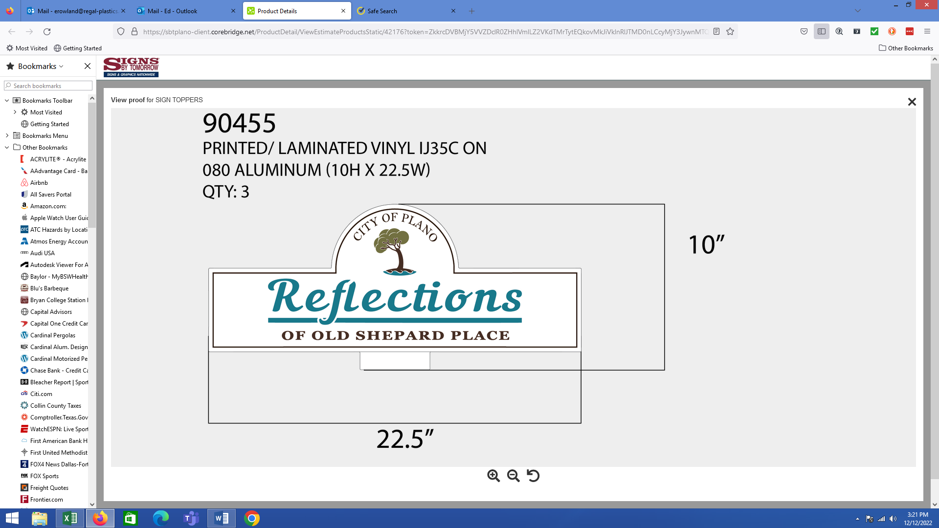

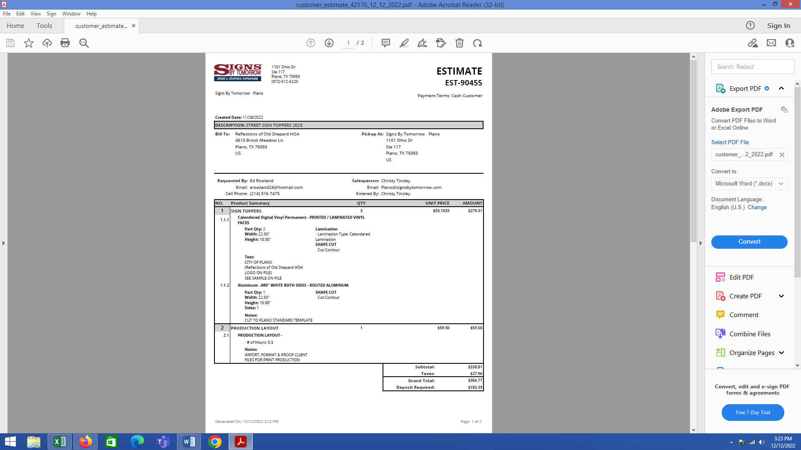

**Queen Victoria Entrance –**

No specific plans at this time.

**Option A:** I recommend removing some of the older worn out and overgrown plants and adding only a few shrubs. Clean out large rocks and cover the gravel with mulch and ground cover to match the adjacent landscaping.

**Option B:** Plant perennial plants in the flower boxes (problem with rabbits eating the flowers)

**Corners at Burnham and Yorkshire-**

We will have a Sign Topper on top of the stop sign at this location in the future.

These corners are private homeowner’s property so anything being considered must have written homeowners approval.

Unlike Old Shepard Road, this intersection is not traveled by the general Plano residents. Therefore, it is unlikely that the City of Plano would approve Grant money to be used at this location.

Installing a rock, with the ROSP logo, at the base of the stop sign would cost about $800 and would not be approved by the City of Plano. COP does not like large rocks in medians and may even decide to remove the rock.

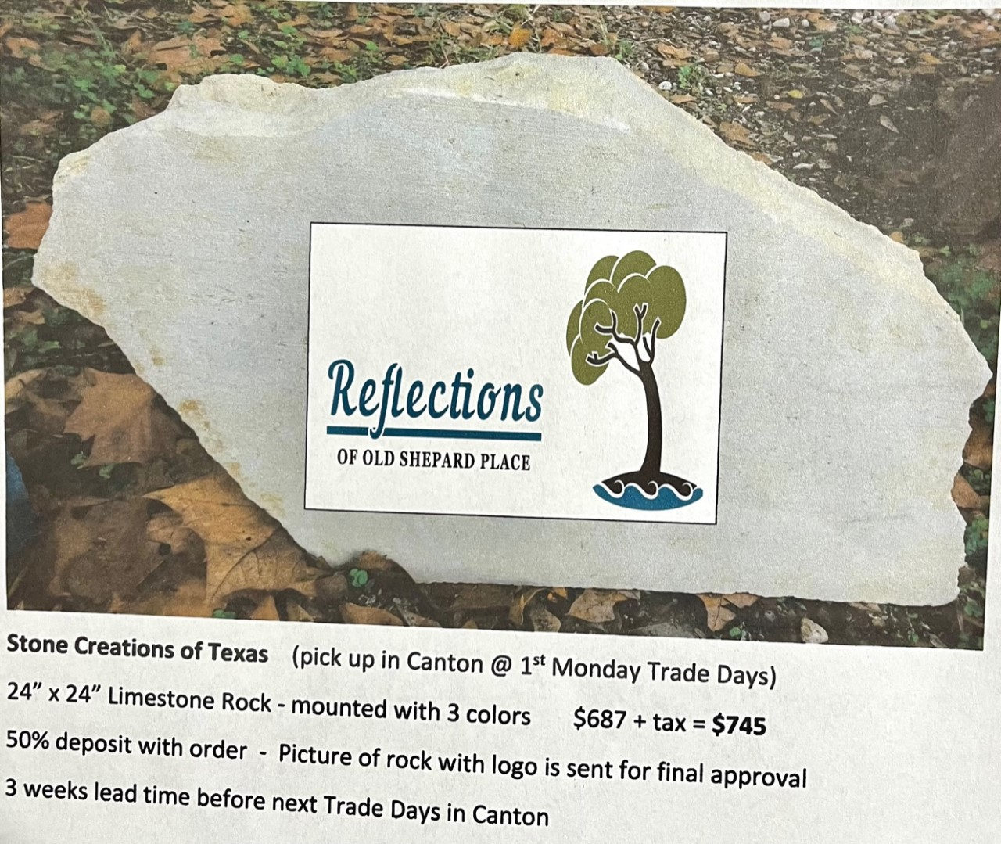

*This is an old quote so pricing may have gone up.

**Yard of the Month –**

Runs April thru September

**Estimated Budgets -**

|  |  |  |
| --- | --- | --- |
| **2023 BUDGET** | **2023** | **2022** |
| Landscaping - planting flowers, new shrubs as needed | $ 2,000.00 | $ 2,000.00 |
| City of Plano Project - Sign Toppers | $ 700.00 | $ 700.00 |
| City of Plano Project - Update corners at Queen Vic | ? | $ 4,300.00 |
| Lawn / Yard Upkeep - monthly mowing, blowing edging, weeding, trimming | $ 5,000.00 | $ 5,000.00 |
| Sprinkler Repair - | $ 500.00 | $ 500.00 |
| Electrical Repair - | $ 500.00 | $ 500.00 |
| Electrical Bills - | $ 420.00 | $ 420.00 |
| Water Bills - | $ 1,250.00 | $ 1,250.00 |
| Alley Cleanup | ? | $ - |
| Neighbor's Front Yard Cleanup | ? | $ - |